< Lab Book 1>

<Ronak Rajput, shrey ahir, neha patel, om patel, manav soni,dhwanit shah>

<Student ID>

<INFO1435>

< Bilal Siddiqi>

<31-05-2024>

# Table of Contents

Table of Contents 2

Lab <1,2,3> - <Lab Name> 3

Part <1(1,2,3) 2(1,2,3) 3(1,2,3)> 3

Description 3

Preparation 3

Observations 3

Screenshots 3

Reflection 3

References 3

# Lab <1> - < Find the STP Root Bridge >

# Part <1>

## Description

In this lab, I, a student studying computer system technician, discover the root bridge of the Spanning Tree Protocol (STP) network and use Cisco Packet Tracer to create a network. It's critical to understand STP in order to guarantee dependability and avoid network loops. We examine the switch configurations in order to identify the root bridge.

## Observations

I must look up each switch's bridge ID (BID), which is made up of its priority value and MAC address, in order to comprehend Cisco Packet Tracer. By choosing the switch with the lowest priority value to serve as the hub for network traffic routing and to provide a topology free of loops, this aids in locating the root bridge. Maintaining network stability and improving network architecture need an understanding of the function of the root bridge. Monitoring spanning tree configurations on a regular basis makes it possible to identify root bridge modifications or failures early on, enabling timely maintenance and troubleshooting to guarantee seamless network operation.

## Screenshots

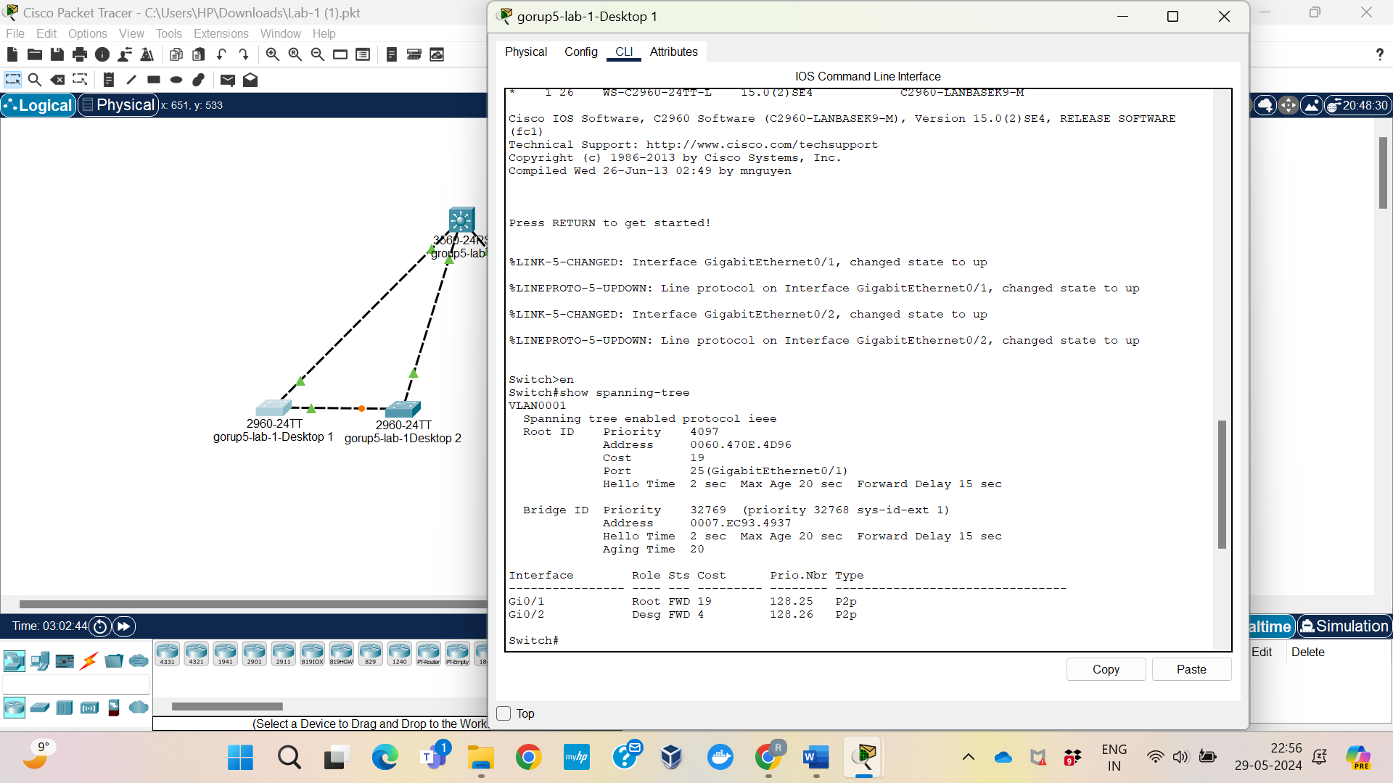

## Reflection

As a student studying computer system technologies, this Cisco Packet Tracer lab has been quite beneficial. I gained a lot of knowledge on the significance of the Spanning Tree Protocol (STP) for maintaining network stability and preventing loops. I learned in the lab to go through switch configurations to identify the root bridge with the lowest priority. It all comes down to maintaining network stability, streamlining its design, and routinely verifying STP setups to identify issues early. My practical abilities for networking and IT maintenance jobs in the real world have come from this hands-on experience.

# Lab <1> - < Configuring the STP Root Bridge >

# Part <2>

## Description

Spanning Tree Protocol (STP) priority for VLAN 1 may be manually changed on the Distribution switch using the command "spanning-tree vlan 1 priority 4096". By setting its priority to 4096, this configuration identifies the Distribution switch as VLAN 1's root bridge.

## Observations

Verify that Distribution is now recognized as the root bridge for VLAN 1 by running the "show spanning-tree" command on each switch in the network after the Distribution switch's configuration was changed. Make sure Distribution's priority value corresponds to the 4096 value that has been set.

## Screenshots

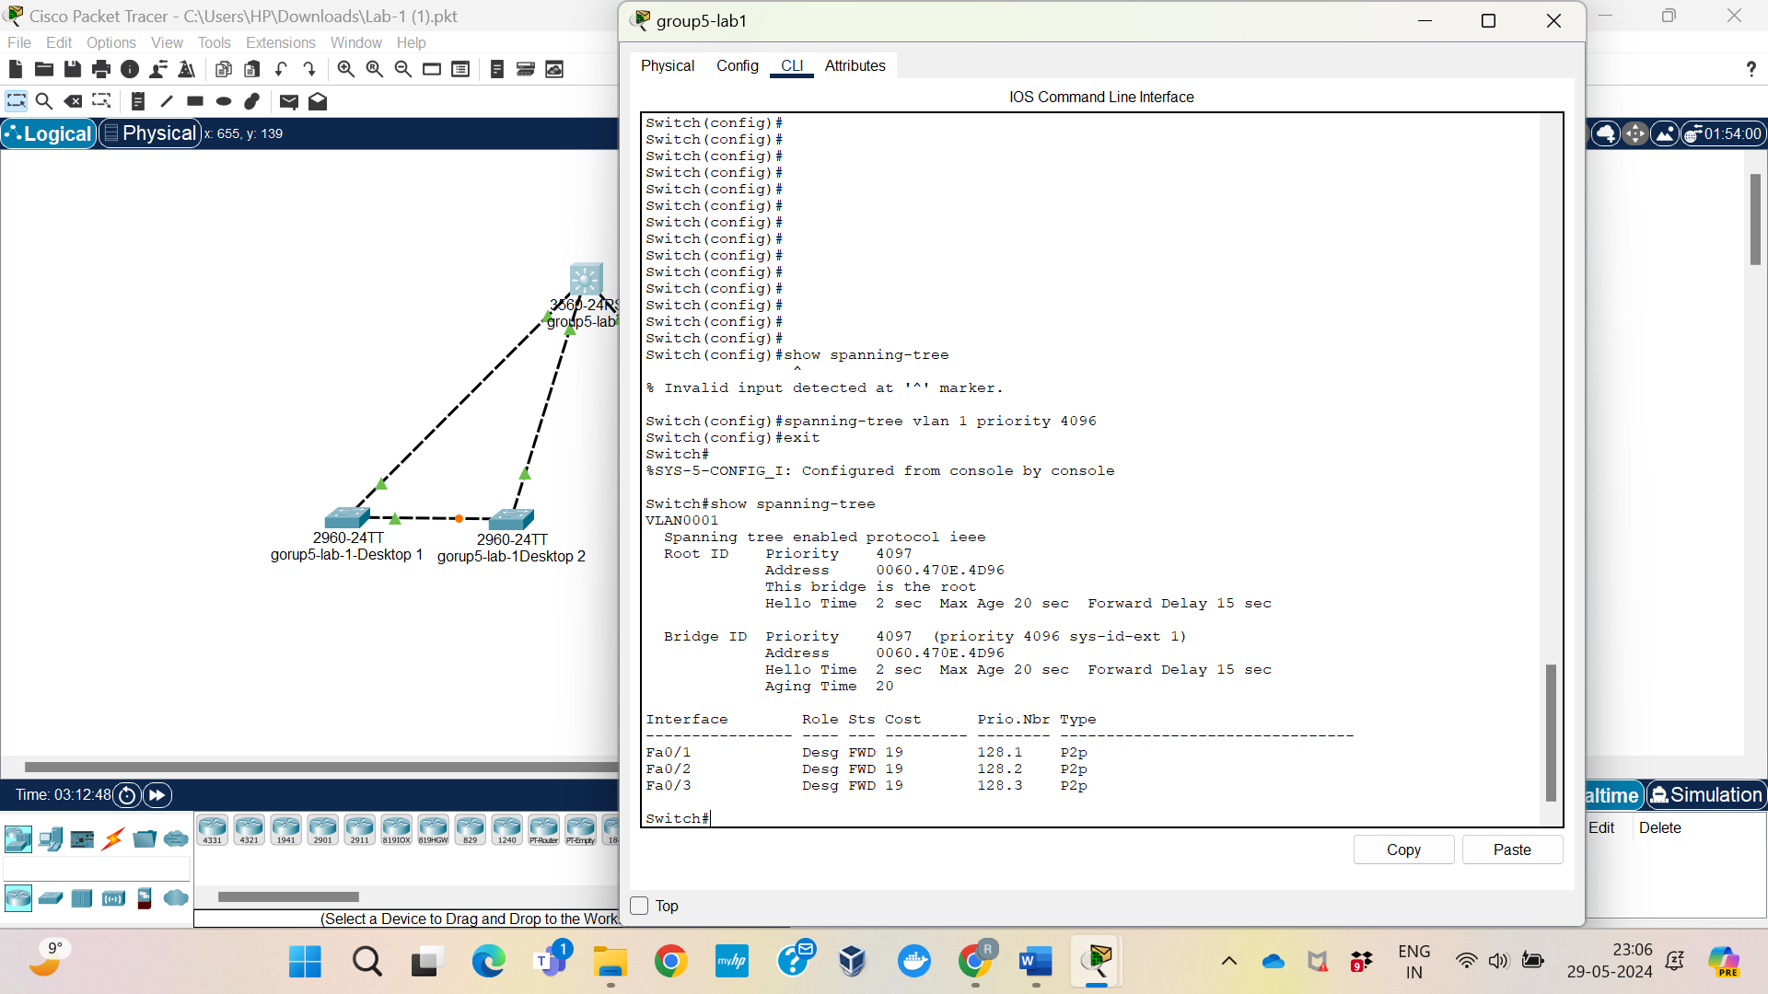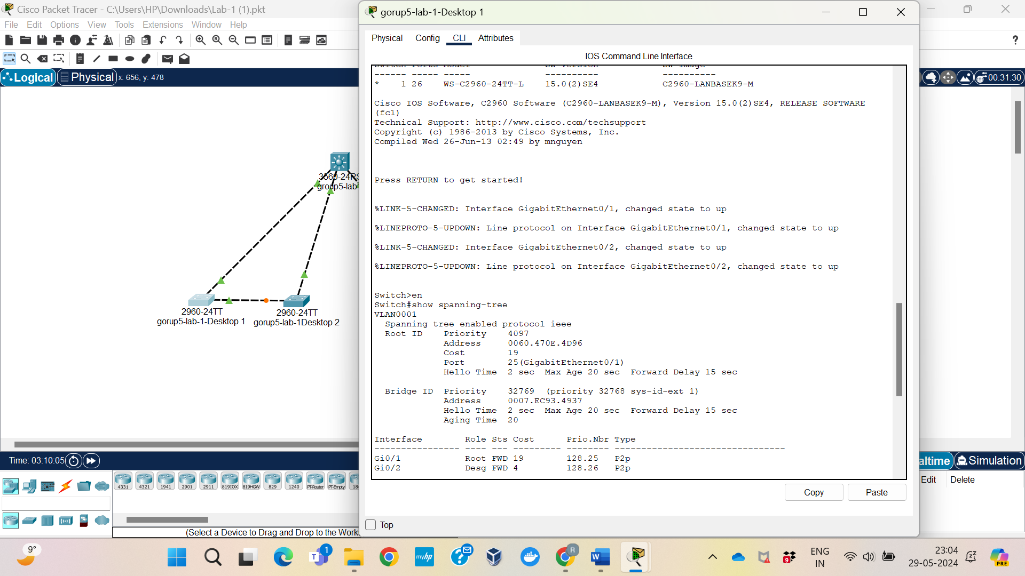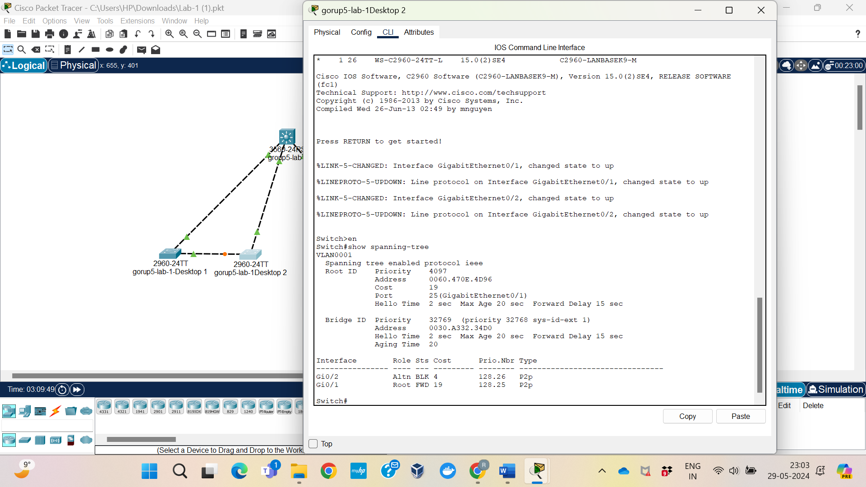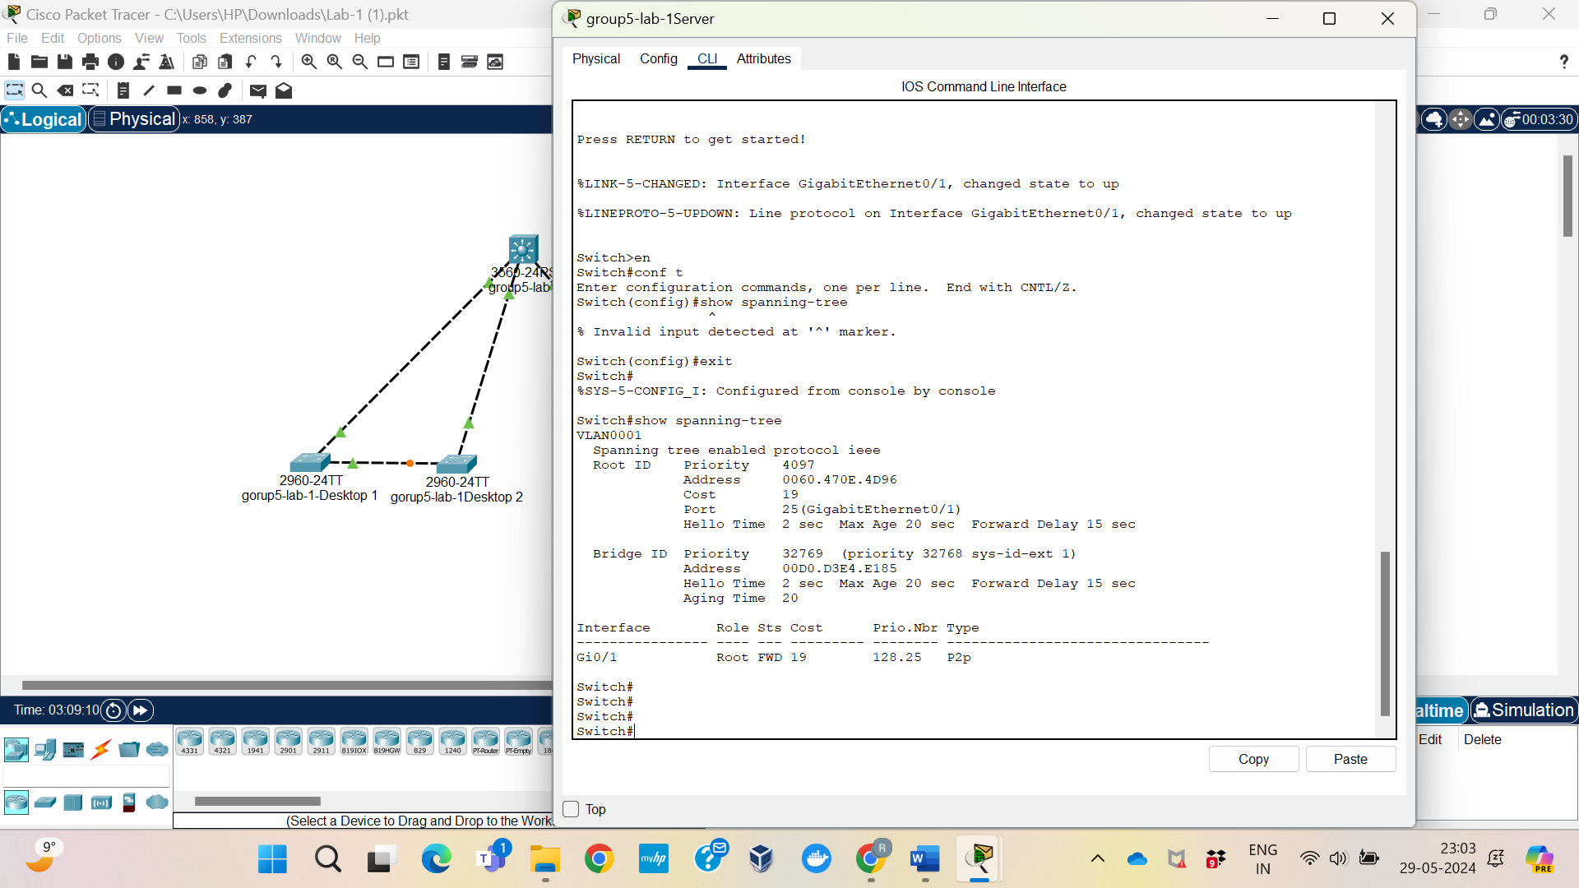

## Reflection

A more manual root bridge selection for VLAN 1 gives you more control over how the network's spanning tree is configured. This strategy makes sure that Distribution is in charge of effectively forwarding traffic and preserving network stability, regardless of whether it is functioning as a core or central switch in the network architecture. By selecting Distribution as the root bridge, network managers may improve overall network performance and traffic management to satisfy the needs of the enterprise.

# Lab <1> - < Observe Spanning Tree Port Roles and States >

# Part <3>

## Description

Observing and comprehending the functions and status changes of ports in a spanning tree network is the goal of the third lab segment. To find out how each port helps to keeping a loop-free network topology by adopting particular roles (Root, Designated, or Non-Designated) and states (Forwarding or Blocking), we will use the "show spanning-tree" command on each switch. Through this procedure, the network's Spanning Tree Protocol (STP) is guaranteed to be properly setup and functional.

## Observations

Make sure the network topology is established correctly and that the Distribution switch is selected as the root bridge in Packet Tracer before continuing with this lab part. By logging into each switch's CLI, make sure you're in the privileged EXEC mode, and make sure the "display spanning-tree" command can be executed on each switch. This command will provide complete STP status information as well as the necessary port responsibilities and statuses for the lab.

## Screenshots



## Reflection

The STP configuration's responsibilities and statuses guarantee effective data paths and avoid loops, ensuring the network's correct operation. In the Forwarding state, Root Ports and Designated Ports help to ensure smooth data flow, while Blocking Ports stop broadcast storm problems. Comprehending these responsibilities and statuses is essential for diagnosing and enhancing network performance. This illustration highlights how crucial STP is for preserving network stability and efficiency by controlling the quantity of data transfer paths.

# Lab <2> - < Find the STP Root Bridge >

# Part <1>

## Description

Using Cisco 2960 switches in Packet Tracer, our goal in the first lab section is to identify the primary switch in our network. We can determine which switch is the primary switch at any one time by using the show spanning-tree command to examine the network's spanning tree and properly configuring ports. Along with determining each switch's distance from the primary one, we'll also verify the functions and conditions of every port that is linked. We can better comprehend the network architecture and ensure proper setup by doing this activity.

## Observations

The output displays the root bridge, or primary switch, together with information on the status and function of each port. Which switch lists its own Bridge ID as the Root ID is how we determine which bridge is the root. In the event that a switch indicates, "This bridge is the root," it is the root bridge. Root Ports are in a forwarding condition and are directly connected to the root bridge. Depending on where they are in the network, other ports may be Non-Designated (Blocked) or Designated (Forwarding). The bandwidth of the connections determines the route cost to the root bridge.

## Screenshots

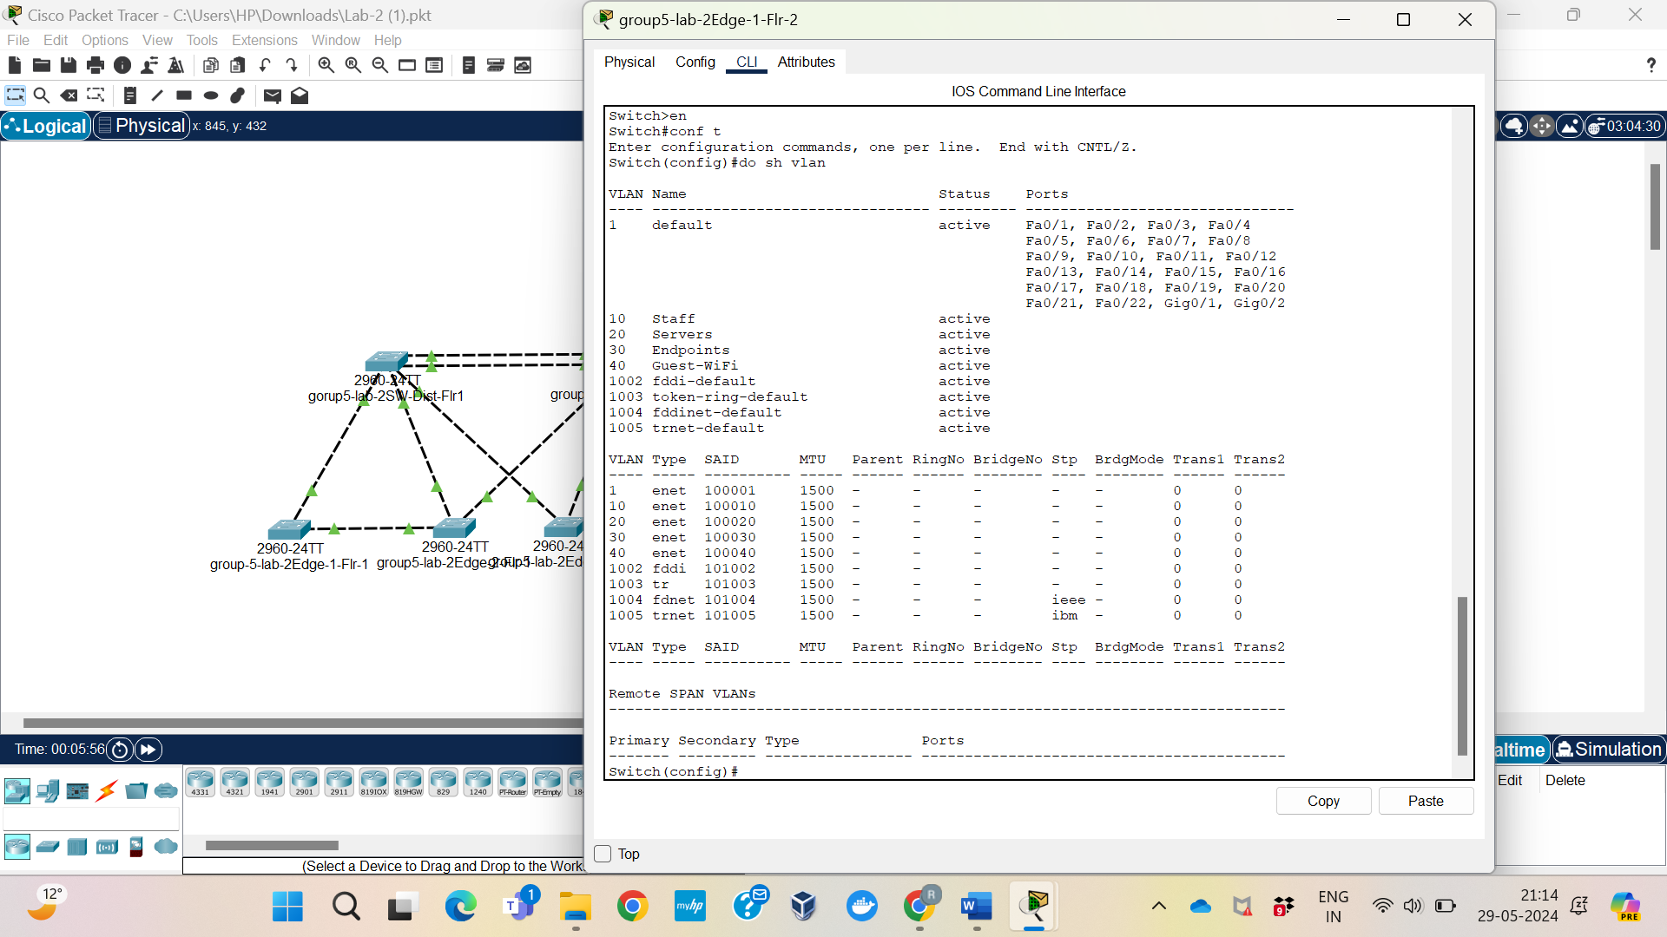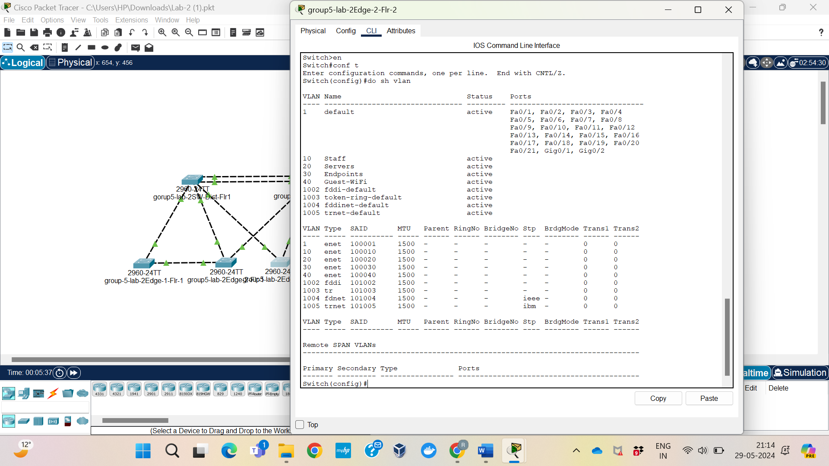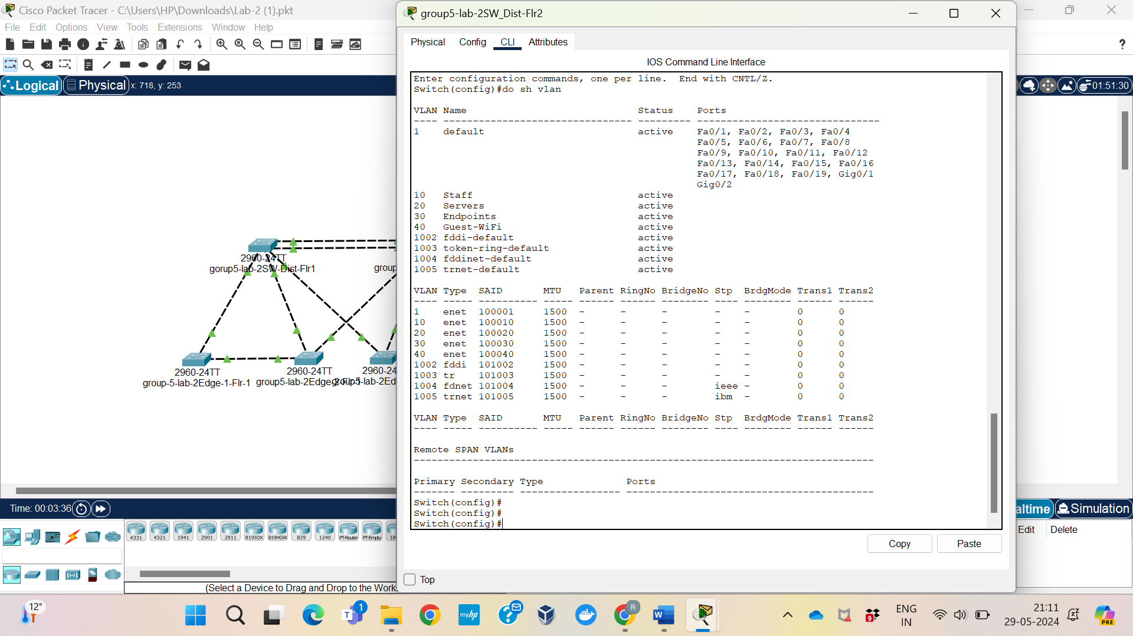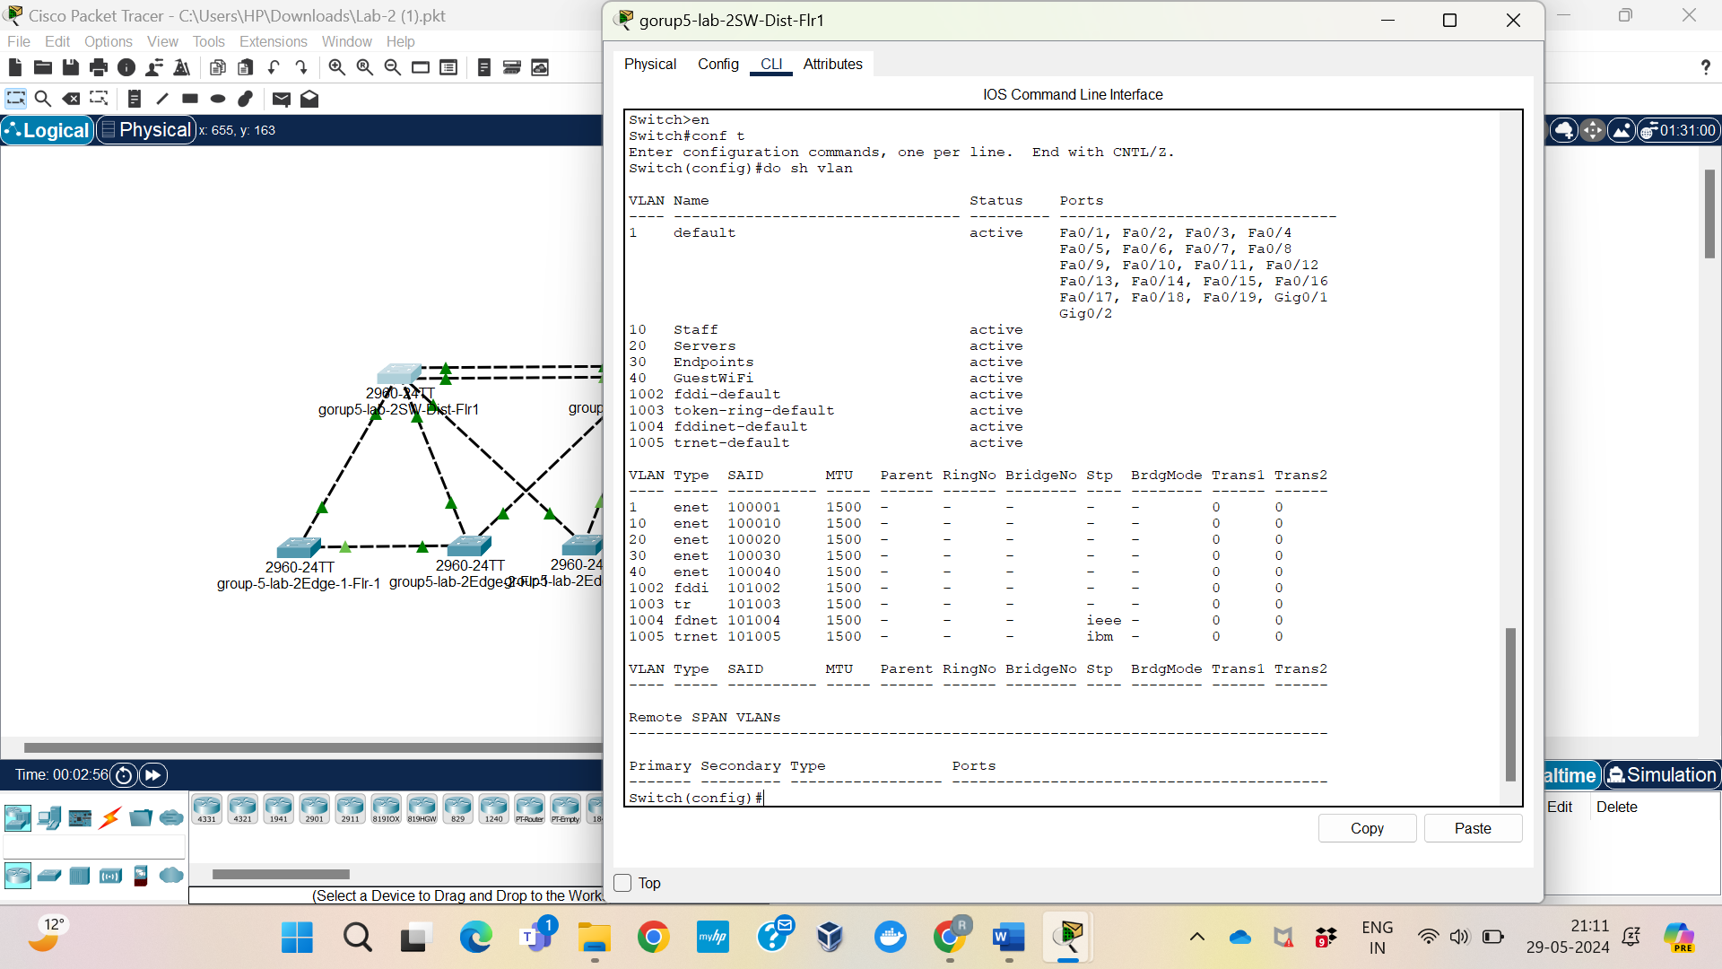

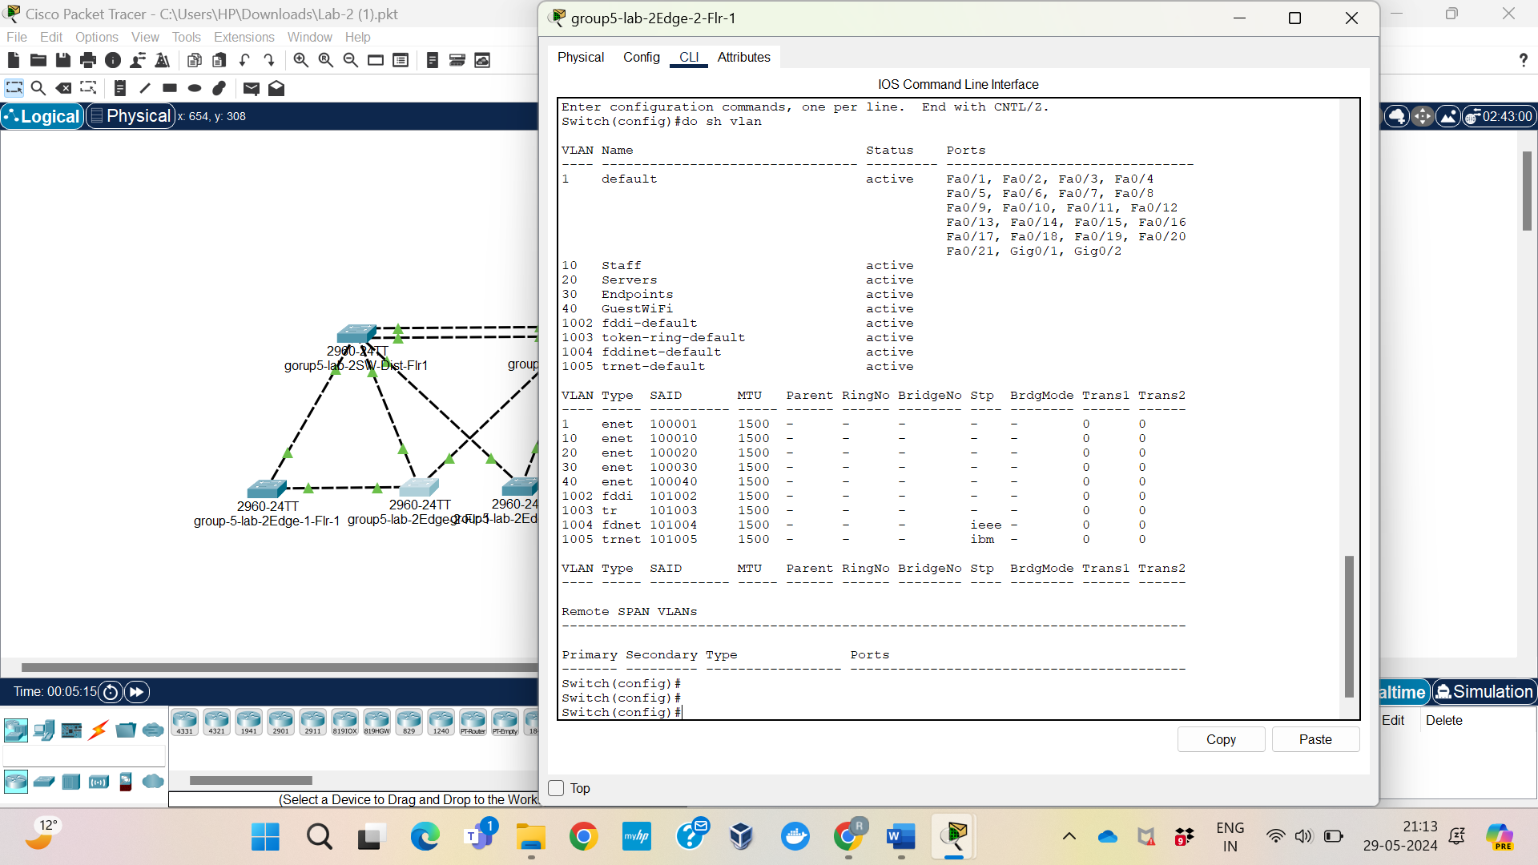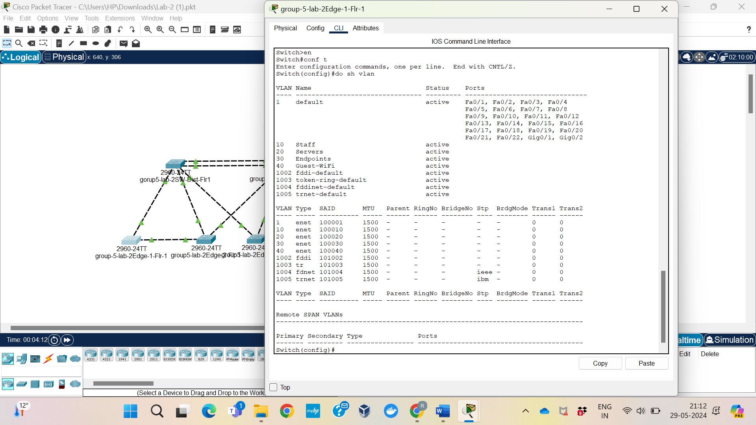

## Reflection

The output shows the root bridge and the roles and statuses of each port after running the show spanning-tree command. Finding the switch with its own Bridge ID as the Root ID reveals the root bridge. When a switch says "This bridge is the root," it means it's the root bridge. Root Ports (Role: Root, State: Forwarding) are directly connected to the root bridge. Other ports may be Non-Designated (Blocked) or Designated (Forwarding) depending on their location in the network. Path costs to the root bridge are based on link bandwidth.

STP keeps the network loop-free by managing port roles and states and calculating path costs. Forwarding state ports ensure smooth traffic flow, while Blocking Ports prevent network loops. Knowing the current root bridge and understanding spanning tree configuration help with network administration and troubleshooting. STP's importance in network design is clear from this experiment, ensuring efficient data routes while maintaining network stability.

# Lab <2> - < Configure Additional VLANs >

# Part <2>

## Description

In this lab segment, we add specific VLANs and configure each switch to enable Per VLAN Spanning Tree (PVST). PVST establishes a distinct spanning tree instance for every VLAN, increasing network redundancy and efficiency. We'll enable PVST, put all linked ports to trunk mode, and construct VLANs 10, 20, 30, and 40 on all switches with names that are selected in order to support multiple VLANs across network lines.

## Observations

The "spanning-tree mode pvst" command was used to configure the switches for PVST. Names such as "Staff" for VLAN 10, "Servers" for VLAN 20, "Endpoints" for VLAN 30, and "Guest WiFi" for VLAN 40 were assigned to the VLANs. Commands such as "interface range <port-range>, switchport mode trunk," and "switchport trunk allowed vlan" were used to set up ports for trunk mode. Through the creation of the designated VLANs, activation of PVST, and configuration of ports to manage numerous VLANs via trunking, appropriate network division and connection were ensured.

## Screenshots

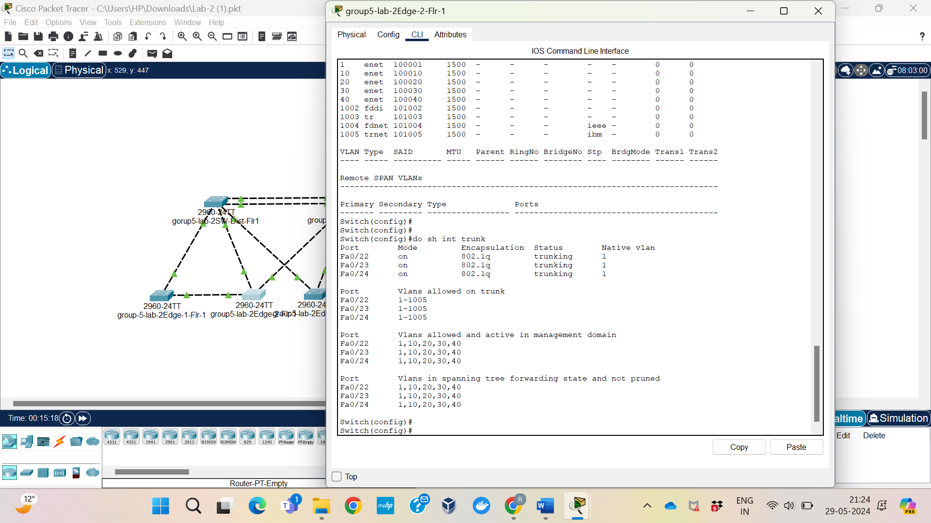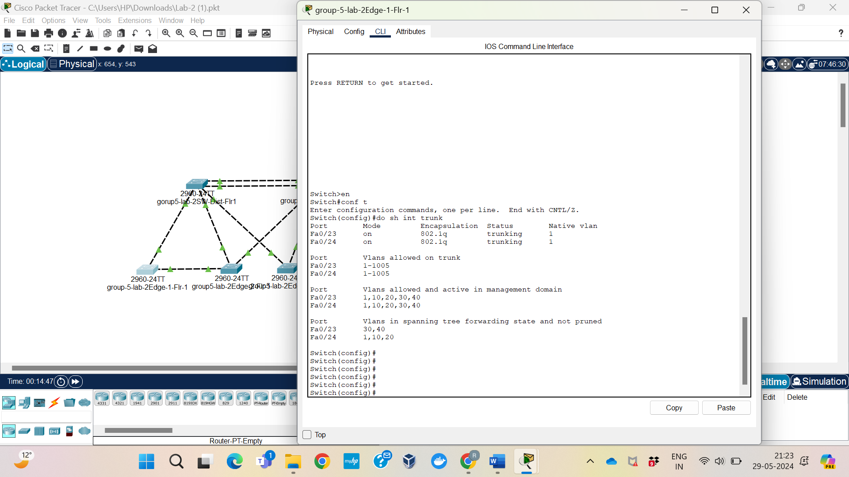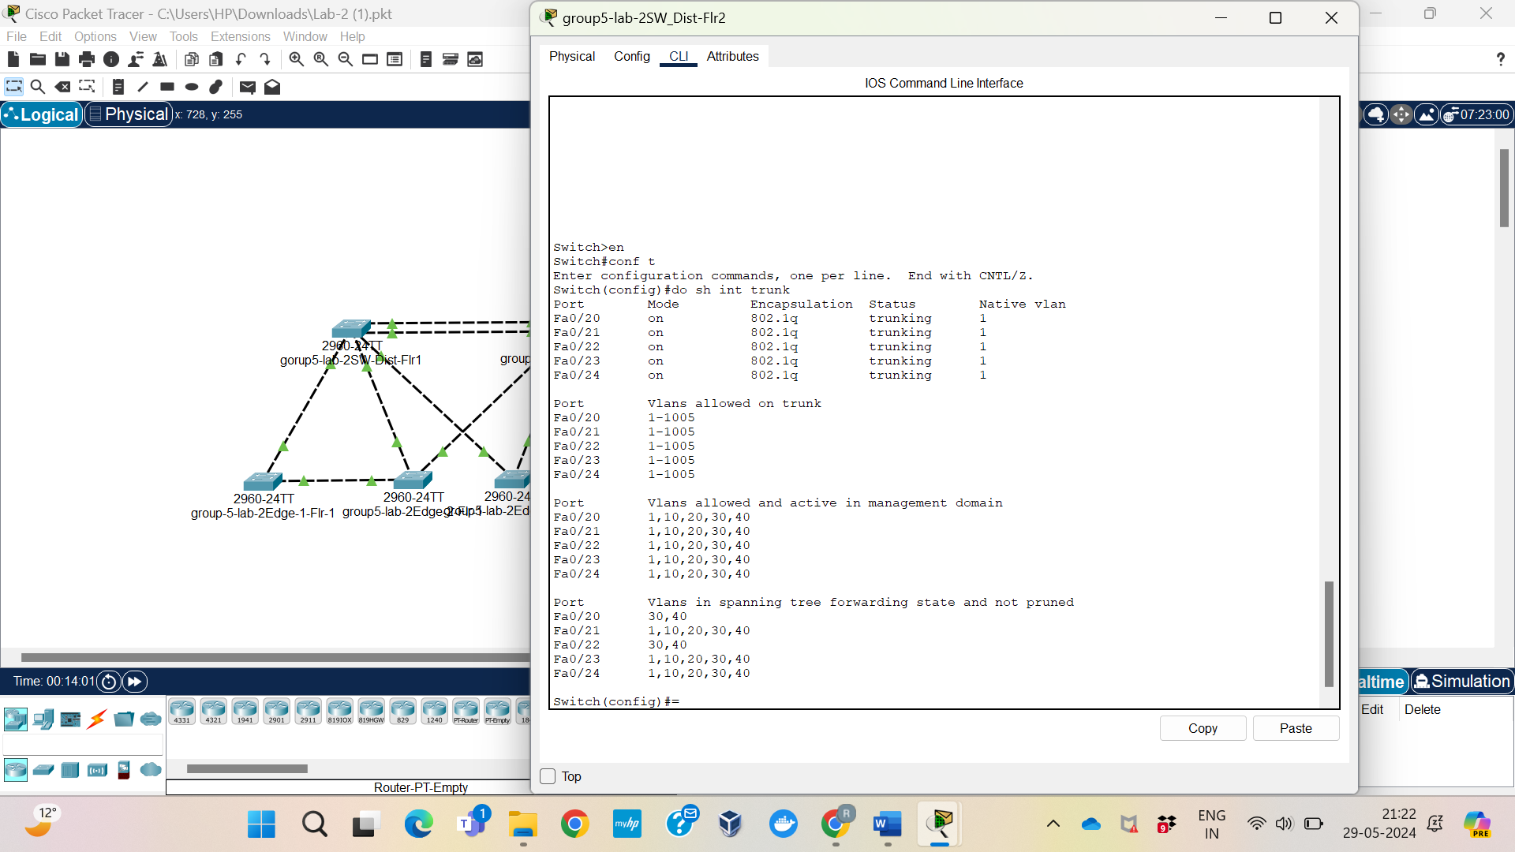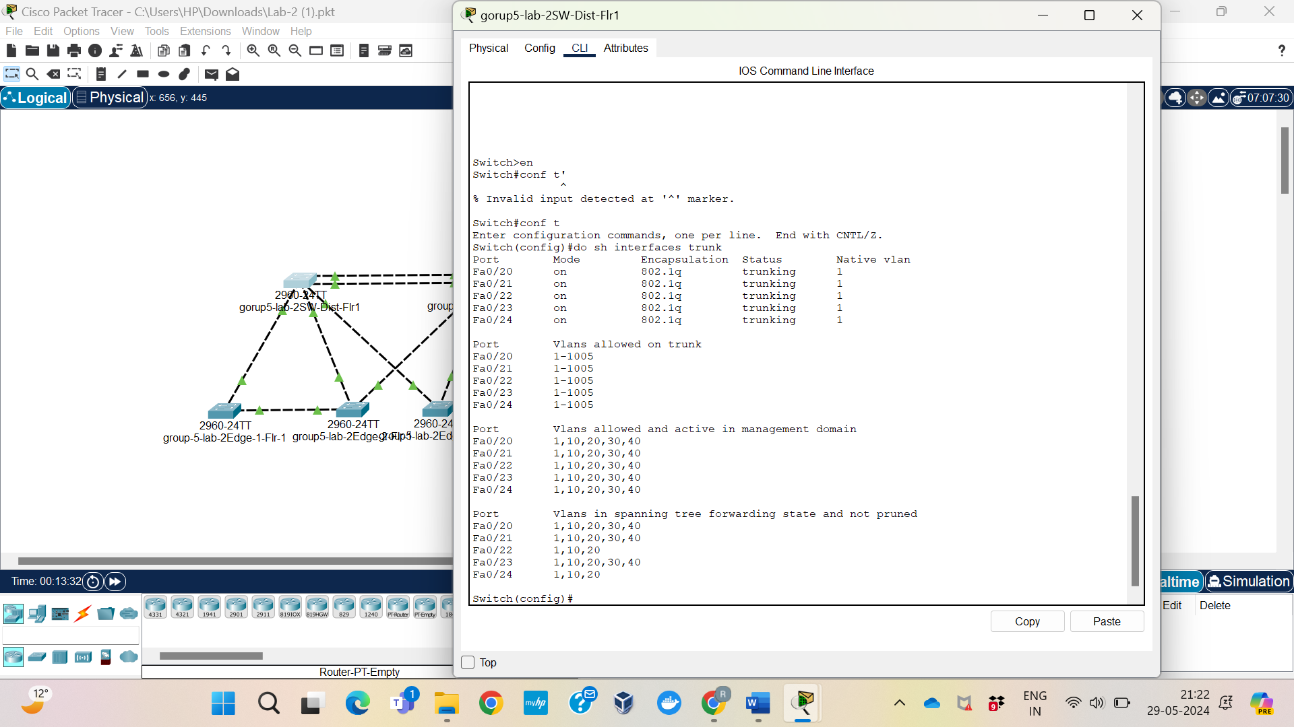

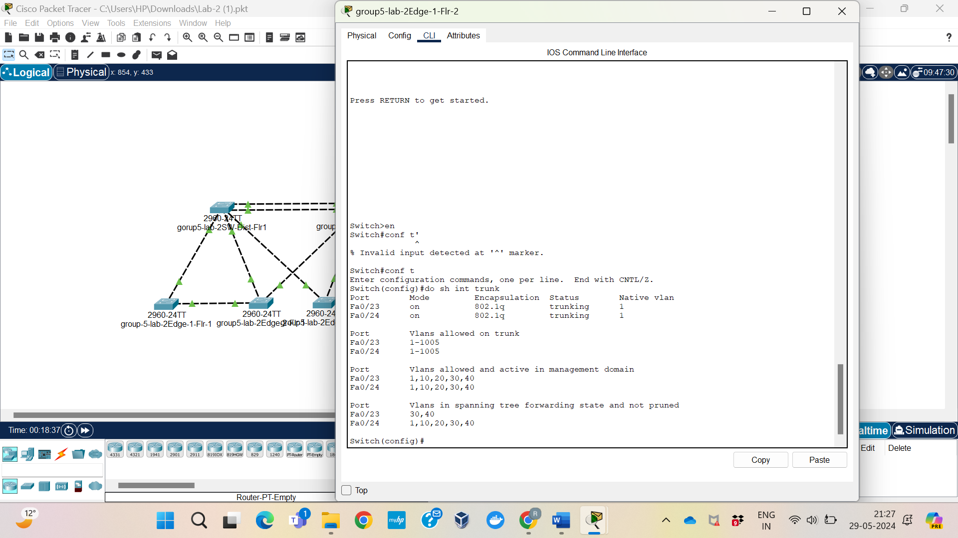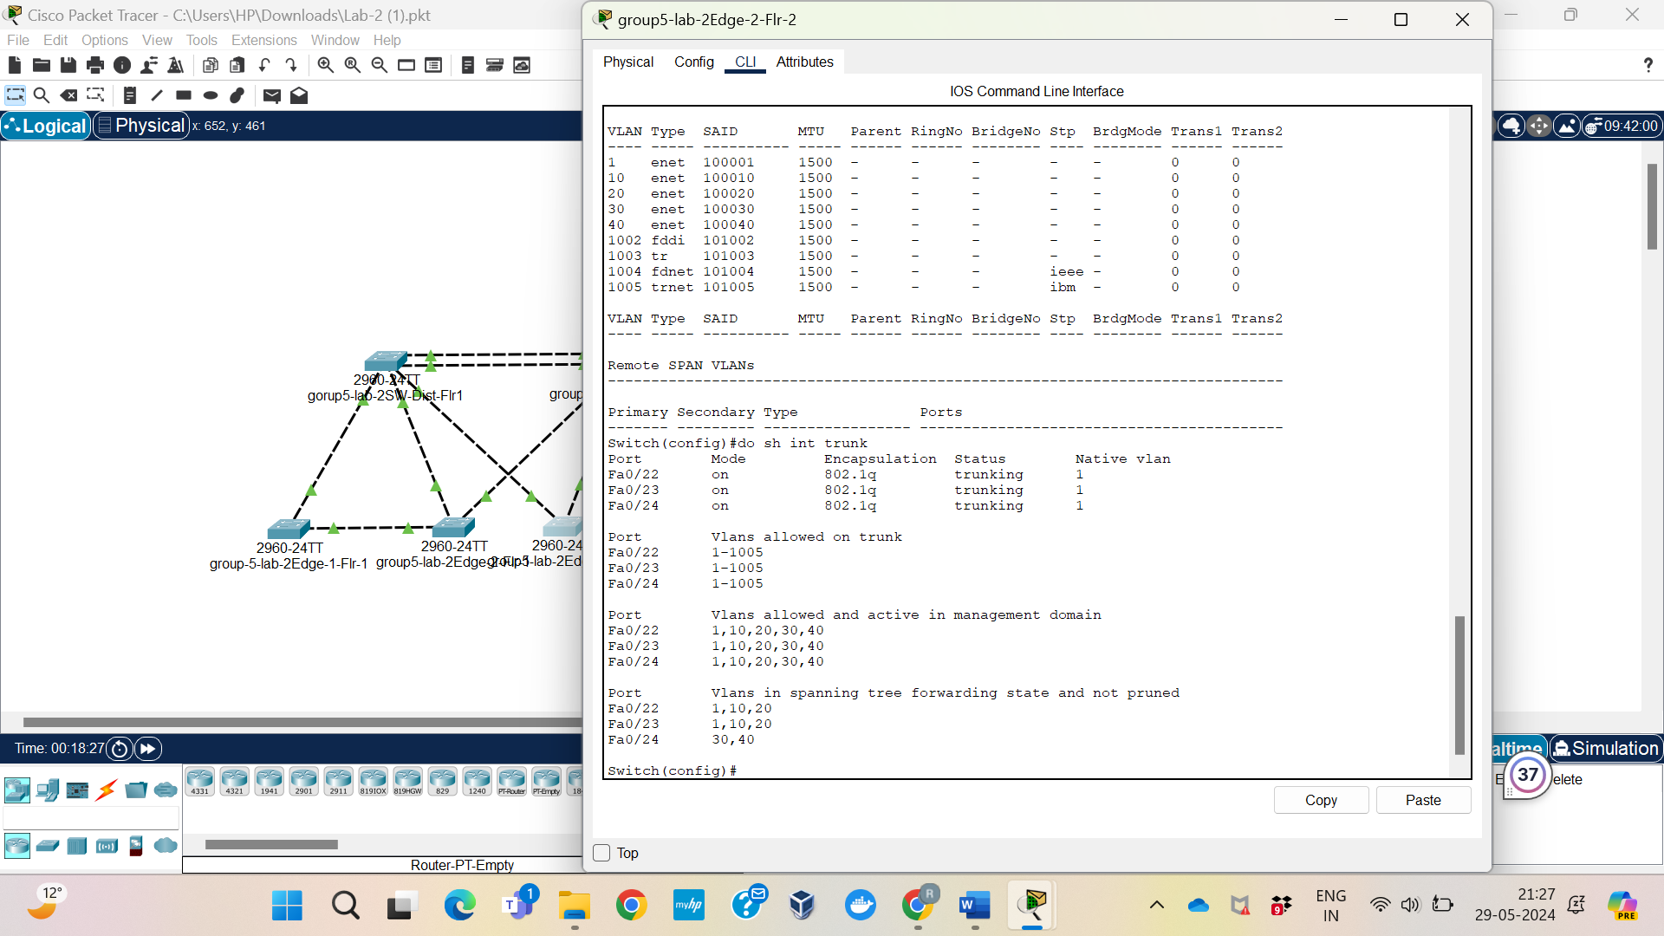

## Reflection

Using Cisco Packet Tracer and putting these setups into practice provides invaluable practical experience in network optimization and administration. Redundancy and network speed are improved by utilizing PVST and creating VLANs. Trunk port configuration highlights how crucial it is for various VLANs to communicate with each other seamlessly. In the actual world of IT, building scalable and effective networks is a critical skill that calls for real-world expertise. These activities emphasize the value of exact network administration and troubleshooting abilities, preparing students for complicated networking responsibilities.

# Lab <2> - < Configure the Root Bridge for Each VLAN >

# Part <3>

## Description

I'll set up particular distribution switches to function as the root bridge for particular VLANs in this lab segment. More specifically, SW-Dist-Flr1 will be the root bridge for VLANs 1, 10, and 20, and SW-Dist-Flr2 for VLANs 30 and 40. By carefully positioning the root bridge for every VLAN, this configuration maximizes the spanning tree topology and guarantees equitable traffic distribution throughout the network.

## Observations

I used the commands "enable," "configure terminal," "spanning-tree vlan 1 root primary," "spanning-tree vlan 10 root primary," and "spanning-tree vlan 20 root primary" to identify SW-Dist-Flr1 as the root bridge for VLANs 1, 10, and 20. Likewise, I used commands like "enable," "configure terminal," "spanning-tree vlan 30 root primary," and "spanning-tree vlan 40 root primary" for SW-Dist-Flr2 to serve as the root bridge for VLANs 30 and 40. Following their setup, I used the "show spanning-tree vlan <vlan-id>" command to make sure that SW-Dist-Flr1 and SW-Dist-Flr2 were configured as root bridges appropriately on each switch. Through this verification, I was also able to examine the responsibilities and statuses of the ports, making sure that the Root Ports were in the Forwarding state and that other ports were blocked or designated as needed to preserve a loop-free network.

## Screenshots

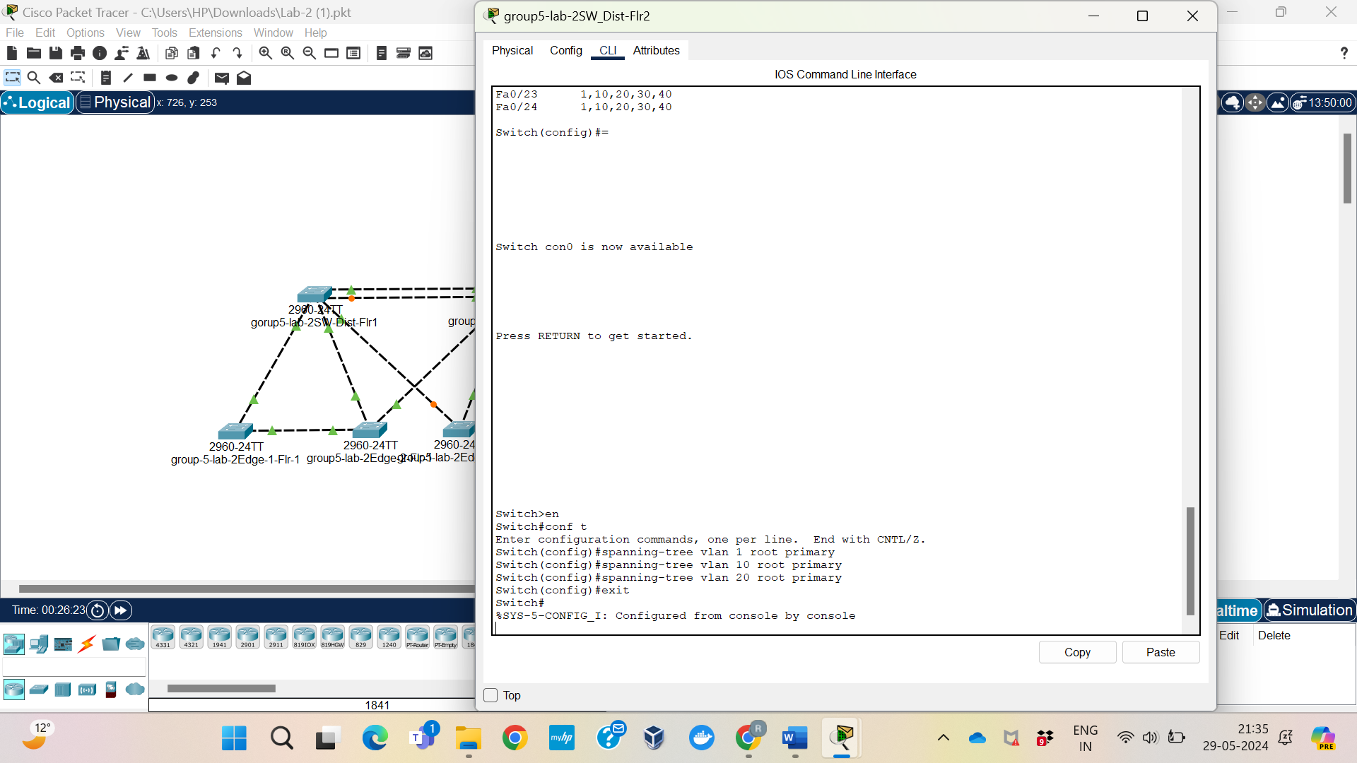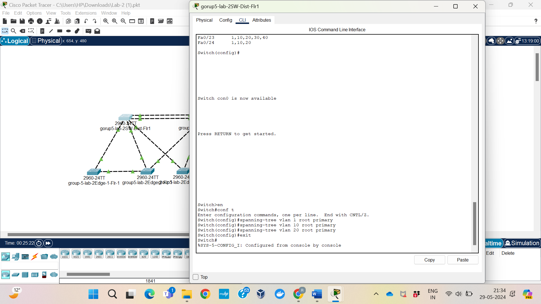

## Reflection

Students' comprehension of spanning tree management in Cisco Packet Tracer and network traffic optimization is improved by configuring particular switches as root bridges for designated VLANs. This example demonstrates how network redundancy and efficiency are affected by the strategic placement of the root bridge. Understanding how STP keeps a loop-free network and guarantees smooth data flow is made easier by looking at port roles and states across various VLANs. Students need this practical expertise to be ready for real-world situations where proper network settings are essential to the upkeep of dependable IT systems. Gaining a grasp of efficient network design and administration requires taking this crucial step.

# Lab <3> - < Prepare for NIC Teaming >

# Part <1>

## Description

This lab's goals are to build a network structure, setup trunking to enable NIC Teaming, and create numerous VLANs, including Staff (VLAN 10), Servers (VLAN 20), Endpoints (VLAN 30), and Guest WiFi (VLAN 40), using Cisco Packet Tracer and 2960 switches. To facilitate network-wide VLAN communication, all linked ports will be set up in trunk mode. In order to guarantee appropriate operation, the observation will also include evaluating the roles and statuses of the ports for each VLAN.

## Observations

When trunking and VLANs are set up on all switches, the Spanning Tree Protocol (STP) is essential for identifying the states and usage of ports. By looking at the results of the `show spanning-tree} command on each switch, we can determine the precise roles and conditions of each linked port for each VLAN. To illustrate its function in forwarding frames for VLAN 10, port Fa0/1 on Distribution Switch 1 might be allocated as the port with a forwarding status for that VLAN. In the meanwhile, port Fa0/2 on Distribution Switch 2 may act as the root port in a forwarding mode, making sure that traffic for VLAN 20 travels over this port in the most effective way possible to reach the root bridge.

## Screenshots

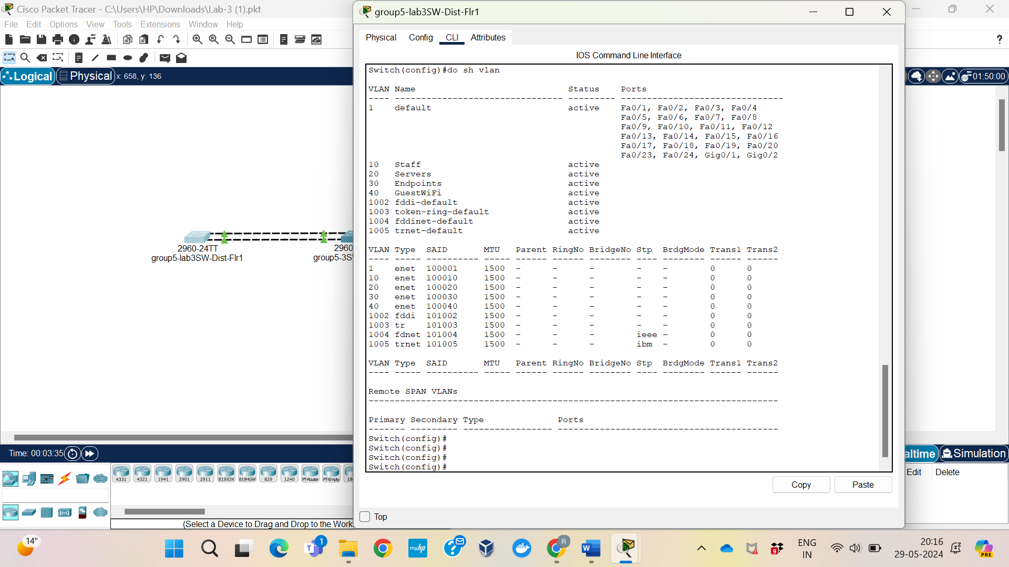

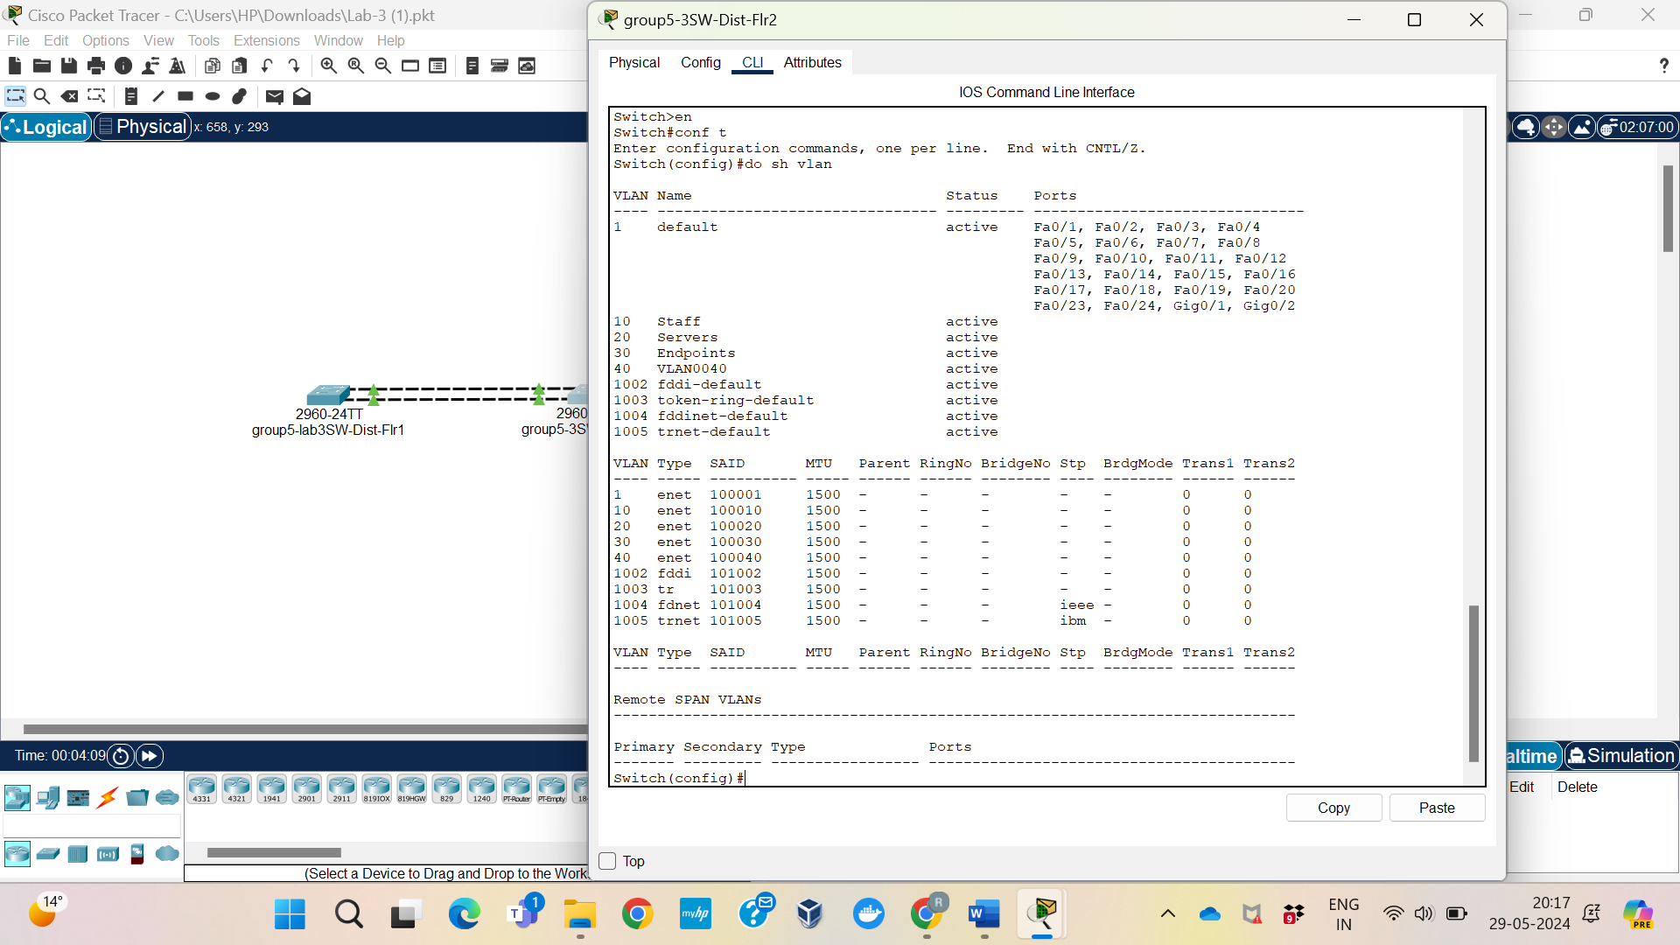

## Reflection

Trunking and VLAN creation are essential for managing network traffic and guaranteeing effective connectivity between various network segments. Enabling NIC Teaming, which offers redundancy and greater bandwidth, requires this configuration. This experiment demonstrated how crucial it is to configure trunks and VLANs correctly. The functions and states of ports show how important the Spanning Tree Protocol (STP) is to preserving a network architecture free of loops. To illustrate the division of labor inside the network, Distribution Switch 1 has a designated port in a forwarding state, and Distribution Switch 2 has a root port in a forwarding state. Comprehending these ideas is crucial to constructing robust and efficient network designs.

# Lab <3> - < Configure NIC Teams >

# Part <2>

## Description

NIC teaming, often referred to as link aggregation or EtherChannel, is the process of integrating several physical network interfaces into a single logical interface. Redundancy and improved capacity are provided by this configuration, which improves network performance and dependability. Link Aggregation Control Protocol (LACP) was set up in this lab to allow NIC teaming between the two distribution switches group5 (SW-Dist-Flr1 and SW-Dist-Flr2). Establishing a channel group on both switches, setting it up to run in trunk mode, and checking the configuration were our objectives. We also looked at how redundancy functions by unplugging a connection to observe how it affected the network.

## Observations

After configuring NIC teaming, we confirmed the configuration using the `show etherchannel summary} command. Information on port channels, channel groups, and their status was given by this command. Our findings showed that ports Fa0/21 and Fa0/22 (with the status flag P) were part of the same port group (Group 1) that was utilizing the LACP protocol. After disconnecting one connection (Fa0/22) the command indicated that Fa0/22 was idle (status flag d) while Fa0/21 remained active (status flag P). When we reconnected the link, the old configuration was restored, demonstrating the redundancy function of NIC teaming.

## Screenshots

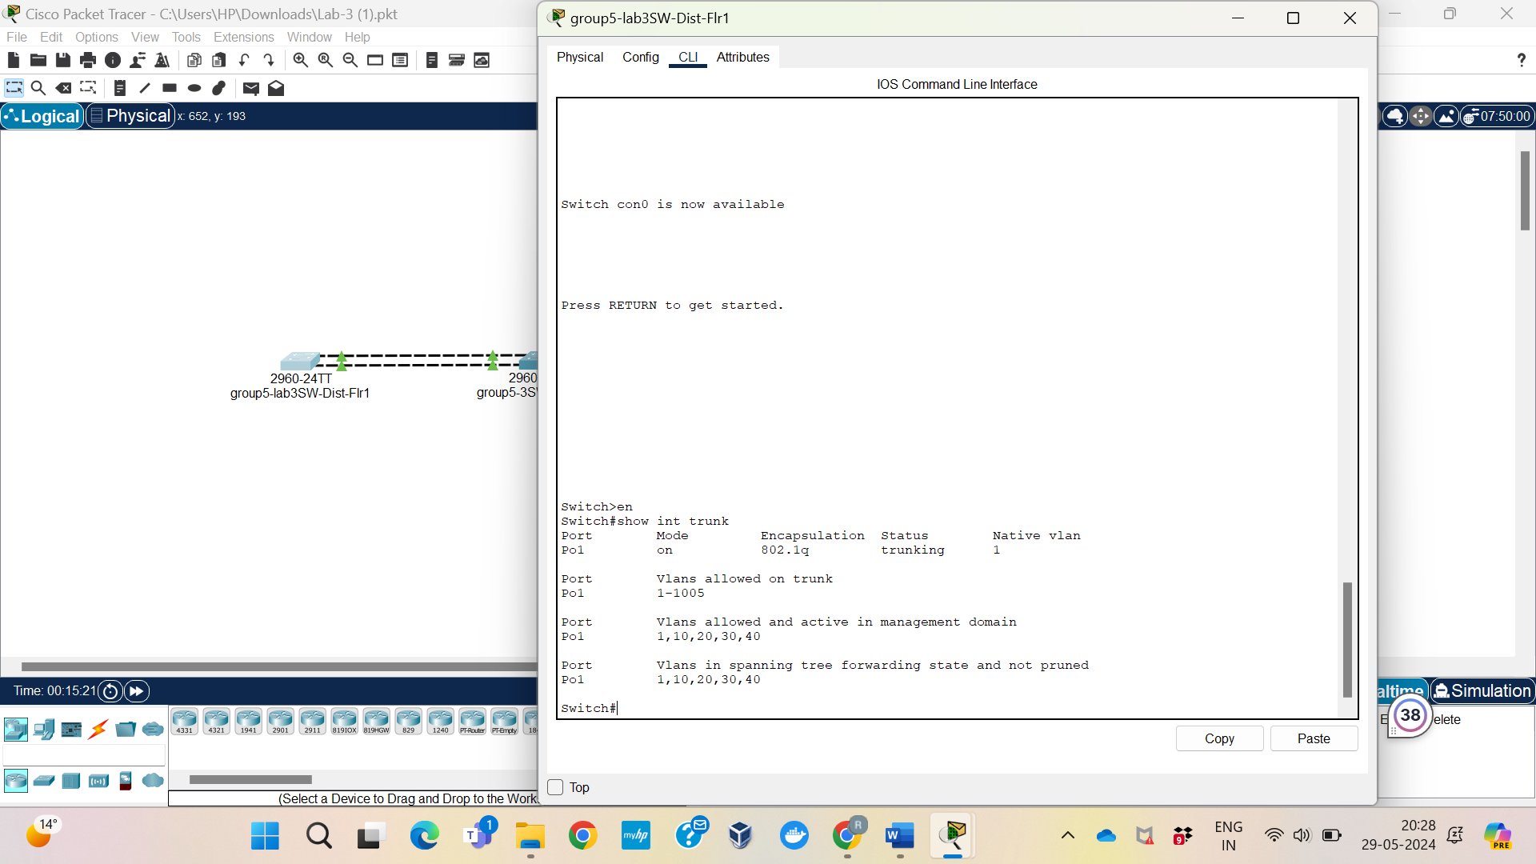

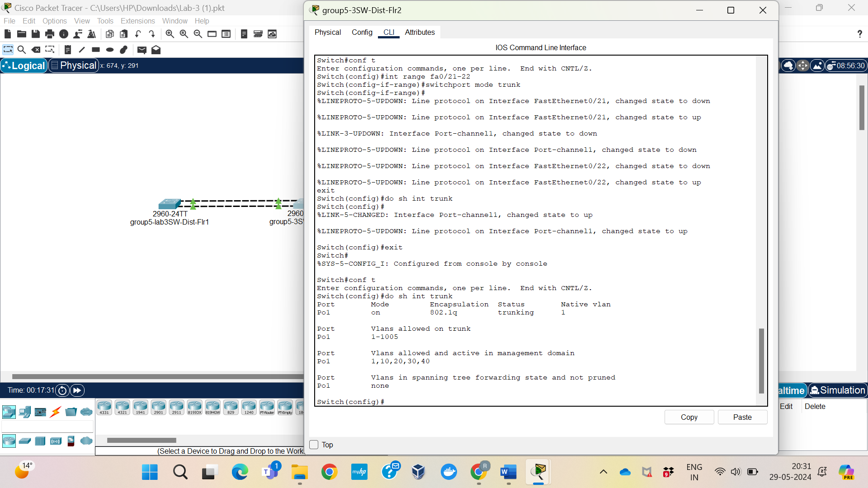

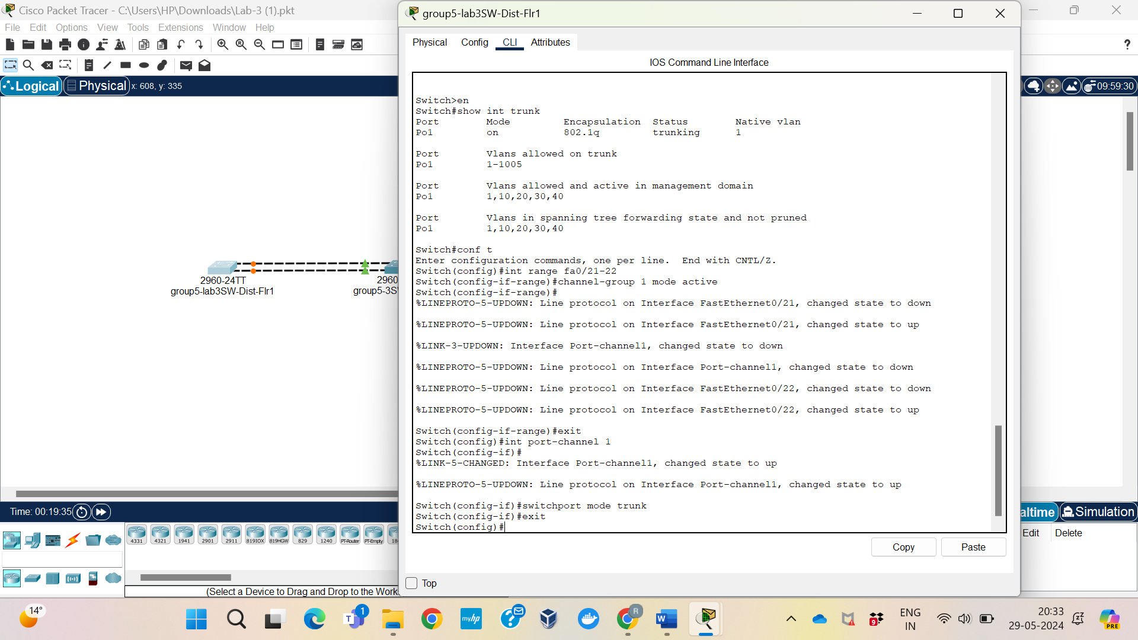

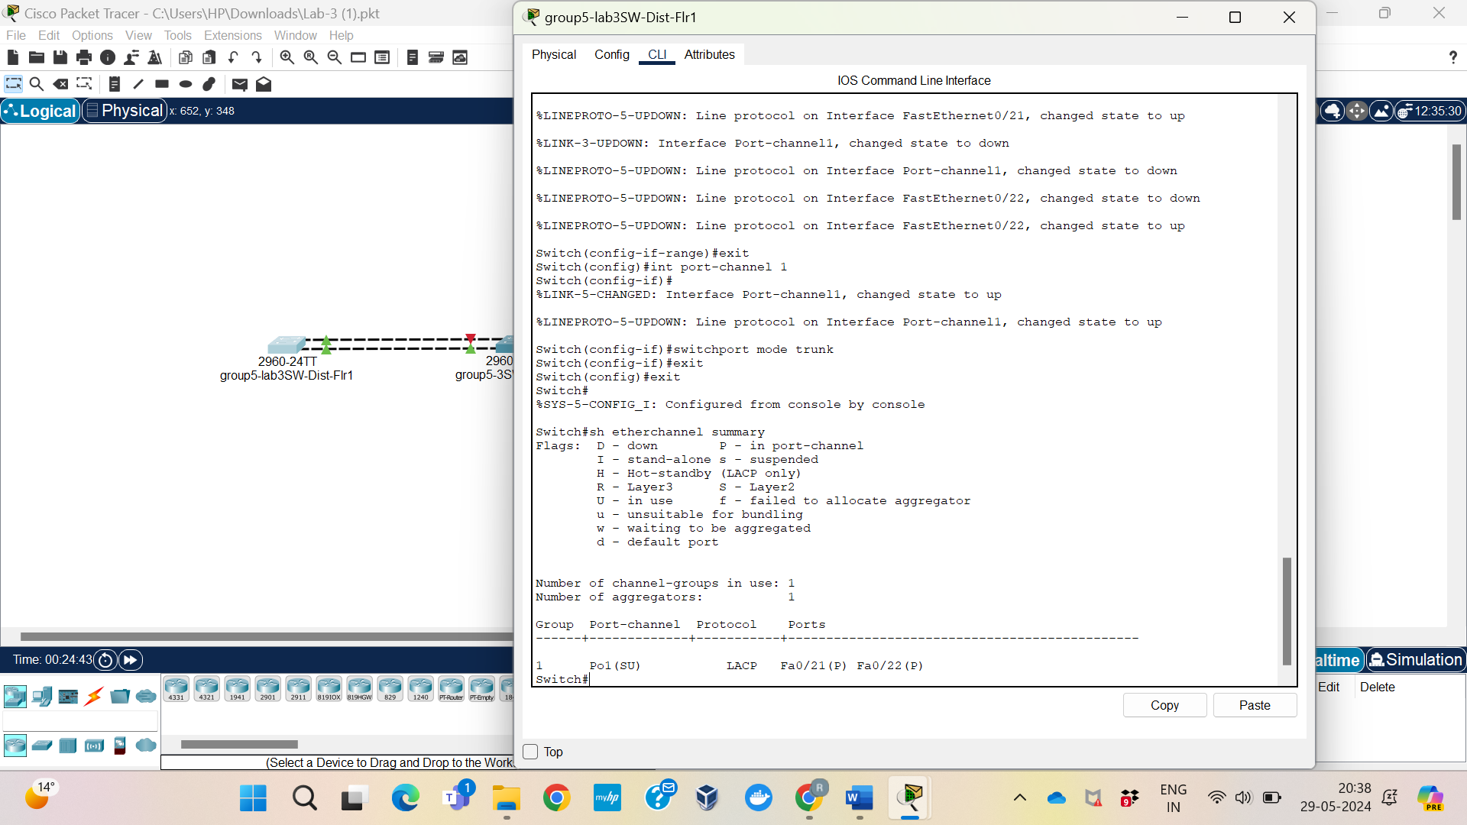

## Reflection

This exercise's NIC teaming configuration made clear how crucial link aggregation is to the functionality and dependability of networks. One logical interface was created by combining many physical interfaces, which increased bandwidth and offered failover capabilities. We could change settings when connections were severed and restore them when they were restored thanks to dynamic management via LACP. This lab demonstrated how NIC teaming improves performance and availability in network architecture. In order to effectively diagnose and maintain networks, it is necessary to understand status flags such as "P" for active ports in the channel and "d" for inactive ports. This highlights the need of accurate configuration and verification methods in network administration.

# Lab <1> - < Observe the Effects of NIC Teaming >

# Part <3>

## Description

Our goal in this lab segment is to evaluate the effects of NIC teaming on trunking and the functioning of the Spanning Tree Protocol (STP). While STP provides a loop-free network architecture by eliminating redundant links, tunneling allows VLAN traffic to flow between switches more easily. To make sure that trunking functionality hasn't been impacted by NIC teaming, we first use the {show interface trunk} command to find trunked ports on both switches. Next, we will study the forwarding and blocking characteristics of STP using the `show spanning-tree} command. Our objective is to confirm that STP keeps the network stable by appropriately classifying ports for forwarding and stopping them according to their states and functions.

## Preparation

We require access to the Command Line Interfaces (CLIs) of both switches in order to comprehend how NIC teaming affects trunking and the Spanning Tree Protocol (STP). utilizing the `show interface trunk} command, we can verify if a switch is trunked by utilizing it to find out which ports are trunked. This guarantees effective VLAN traffic flow between switches and verifies that trunking functionality has not been interfered with by NIC teaming. Next, we will evaluate STP's performance using the `show spanning-tree} command. We'll check if STP can keep the network architecture clear of loops by appropriately classifying forwarding and blocking ports according to their respective responsibilities and statuses. We are able to systematically monitor network activity and guarantee its stability and efficiency thanks to this methodical methodology.

## Observations

By examining the output of the `show interface trunk} command on both switches, we can determine which ports are trunked. Effective VLAN traffic distribution requires trunking, and keeping an eye on trunked ports guarantees best-in-class network resource use. Next, we'll watch STP in action with the {show spanning-tree} command. By assigning forwarding and blocking ports as needed, STP efficiently avoids network loops. We'll take a careful look at each port's functions and states.

## Screenshots

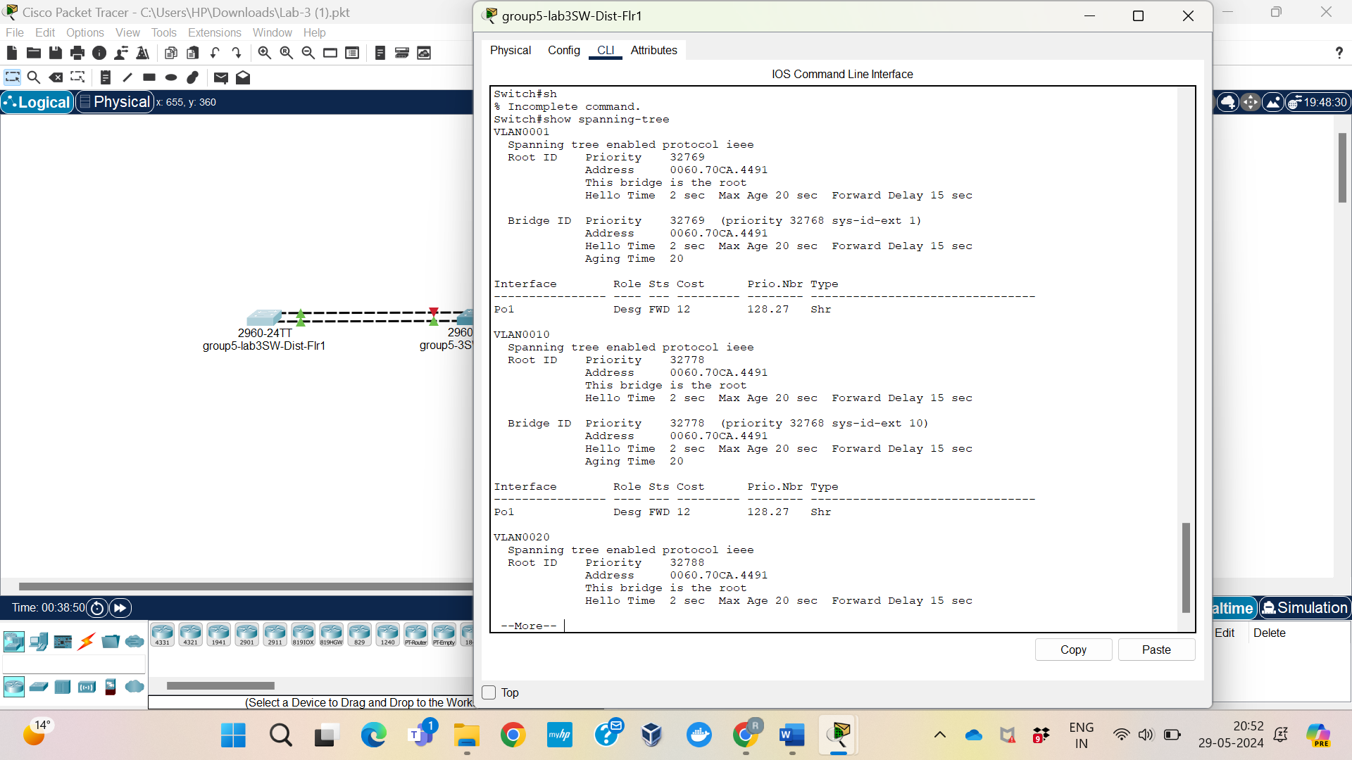

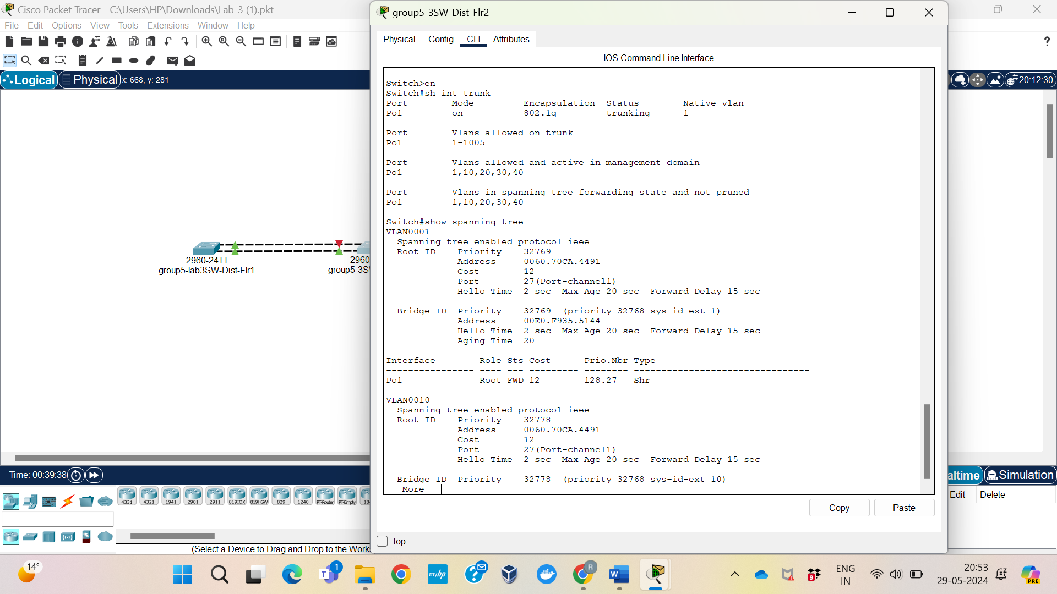

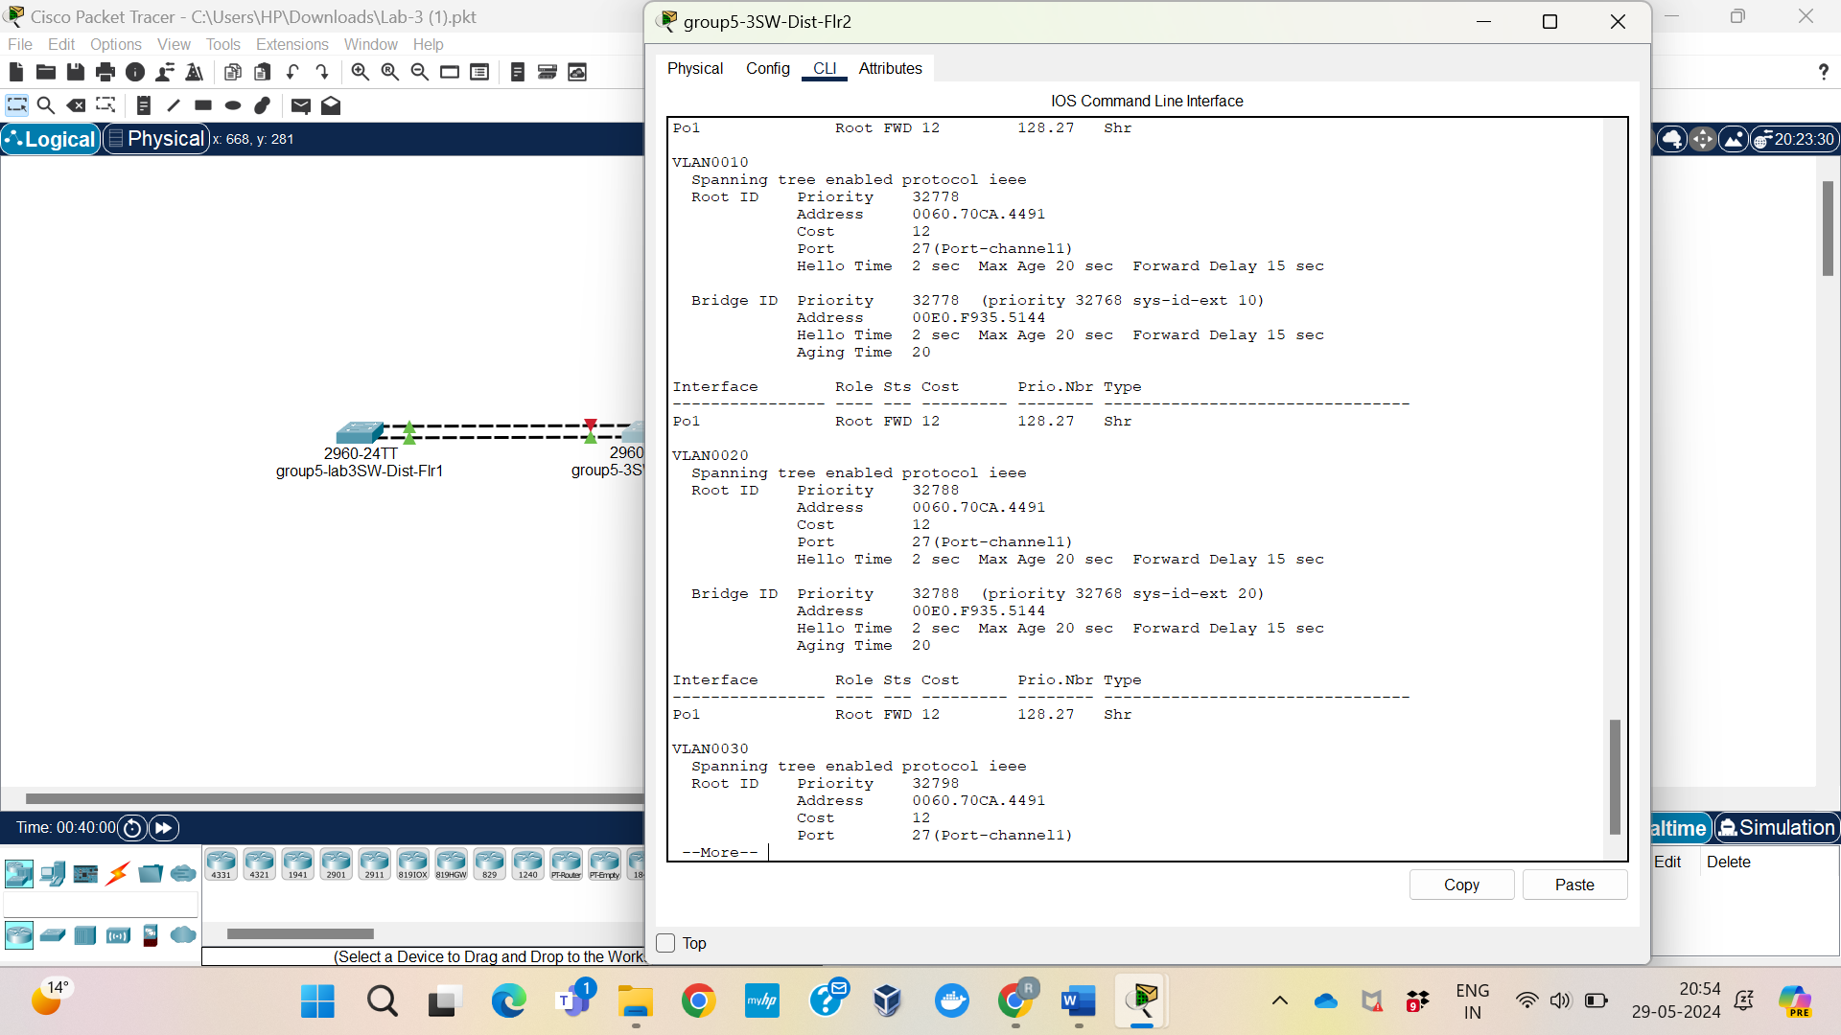

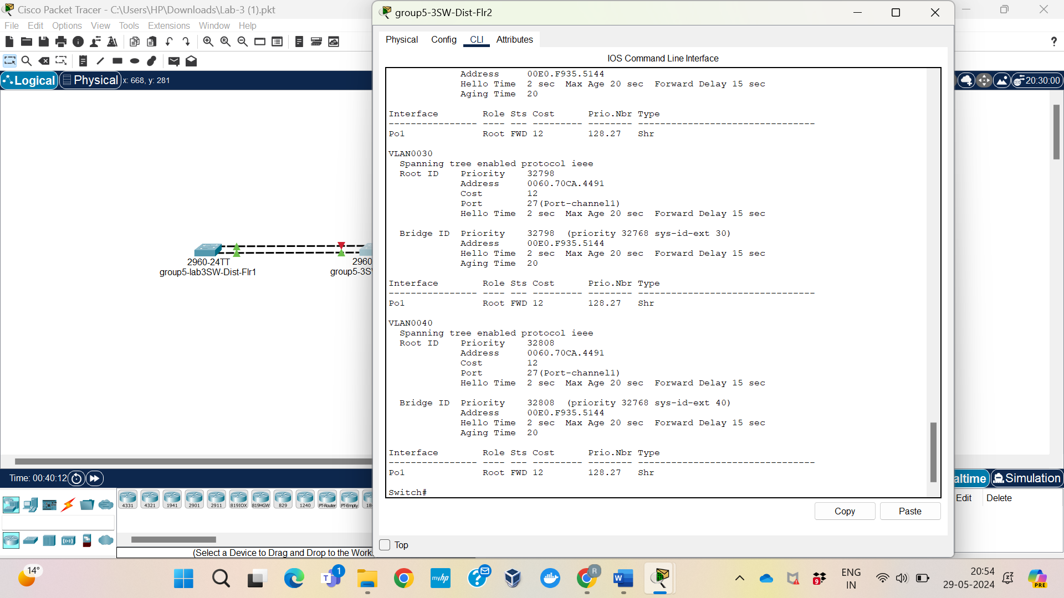

## Reflection

We are watching the impact of NIC teaming on trunking and STP operation, highlighting the significance of network stability and efficiency. Trunking enhances performance by efficiently handling VLAN traffic, but STP preserves network integrity by averting loops. Comprehending the roles and conditions of ports makes troubleshooting and maintenance easier, which is crucial for network management. The need of correct design and monitoring for dependable and stable network functioning is emphasized by this exercise.